**Mater Foundation**

**CI/CD Pipeline – Create DSS/BCA Pipeline**

Version 1.0

**Access List**

*Required for Confidential, Highly Confidential and Secret documents.*

|  |  |  |
| --- | --- | --- |
| **List of Users** | **Access Type** | **Involvement** |
| **(Read, Read/Write)** | **(Implementer, Affected)** |
| Avanade Mater Foundation | Read/Write | Implementer |
|  |  |  |
|  |  |  |

**Document Revision History**

|  |  |  |  |  |  |
| --- | --- | --- | --- | --- | --- |
| **Document Version** | **Approval Date** | **Revised By** | **Reviewed By:** | **Approved By:** | **Summary of Revision** |
|  |  |  |  |  |  |
|  |  |  |  |  |  |
|  |  |  |  |  |  |

Table of Contents

1. Pre-requisites when creating Engagement 4

1.1 Azure DevOps Account 4

1.2 Dynamics 365 CE Account 4

1.3 Azure DevOps Project Admin PAT 4

1.4 Azure DevOps Project (Uninitiated Empty Repo) 4

2. Create Engagement 4

2.1 Create Engagement 4

3. Installing Tools 7

3.1 Visual Studio Code 7

3.2 Visual Studio Professional 2022 or Visual Studio Enterprise 2022 7

3.3 Install Tools (Manual) – refer to 3.4 for automatic installation 7

3.4 Install Tools (Automatic using BizApps CLI) 7

3.5 Install NPM 8

4. DSS/BCA Source Code 8

4.1 Update the Environments on Configuration.json 8

4.2 Connection Strings 8

4.3 Dataverse Deploy 8

4.4 Create Front End Solution 9

4.5 Create Back End Solution 9

4.6 Create MS Flows Solution 9

5. Pipeline Library 11

5.1 Dataverse Secrets 11

6. Environment Deployment Approver 11

1.1 Approval and Checks 11

7. Reference/s 12

1.2 BizApps Core Accelerator 12

# Pre-requisites when creating Engagement

## Azure DevOps Account

## Dynamics 365 CE Account

## Azure DevOps Project Admin PAT

A guide how to generate a Personal Access Token can be found [here](https://docs.microsoft.com/en-us/azure/devops/organizations/accounts/use-personal-access-tokens-to-authenticate?view=vsts)

## Azure DevOps Project (Uninitiated Empty Repo)

# Create Engagement

## Create Engagement

1. Login to <https://platform.avanade.com/engagements>
2. Insert Engagement Name and Select Engagement Category

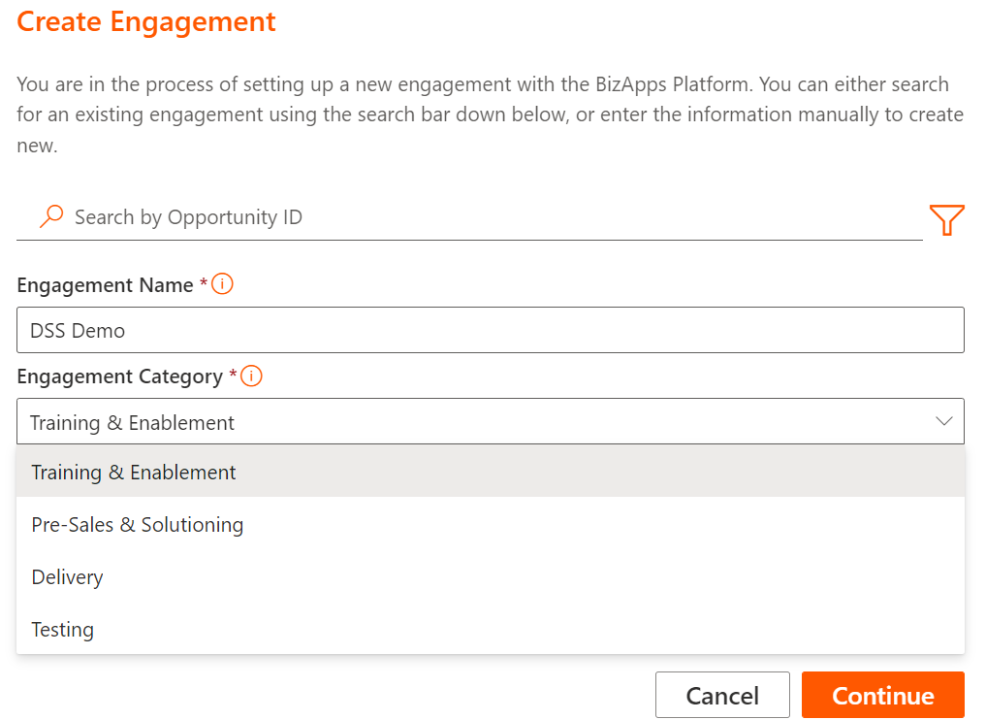

1. Insert Engagement Type

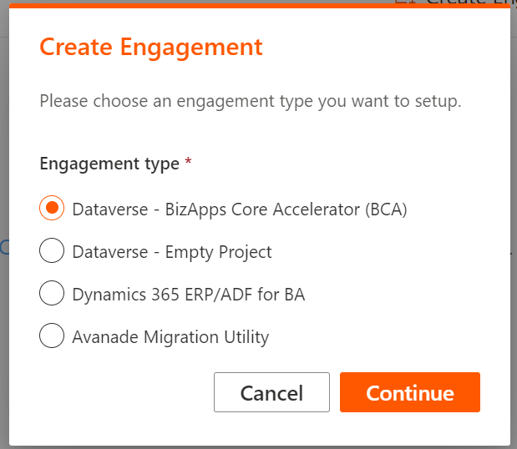

1. Login with your Azure DevOps Account and D365

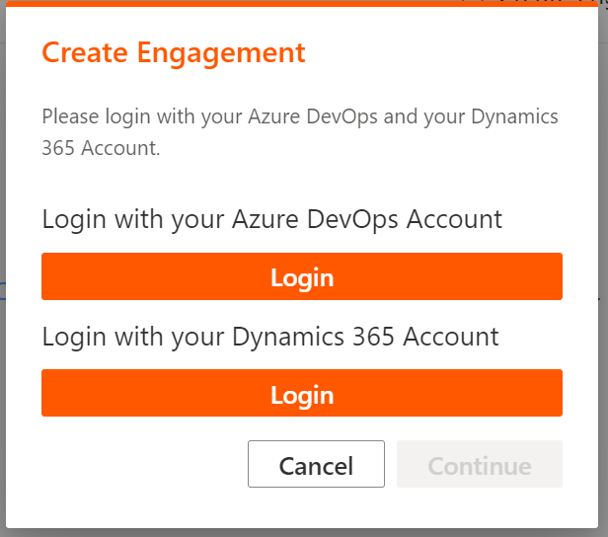

1. Select Setup Style

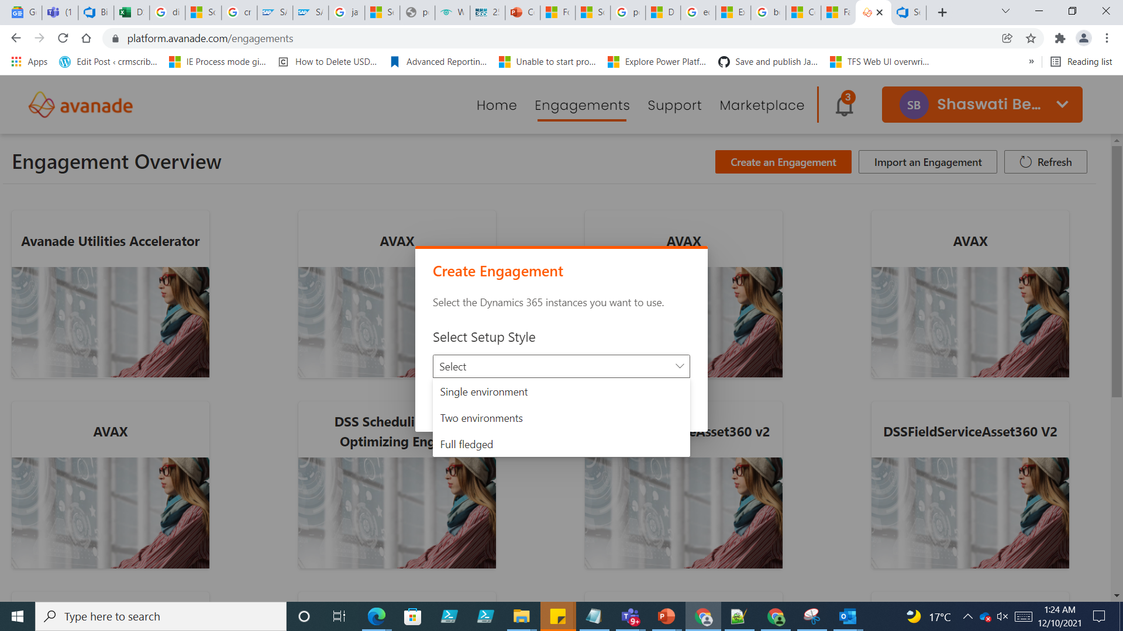

1. Setup D365 instances

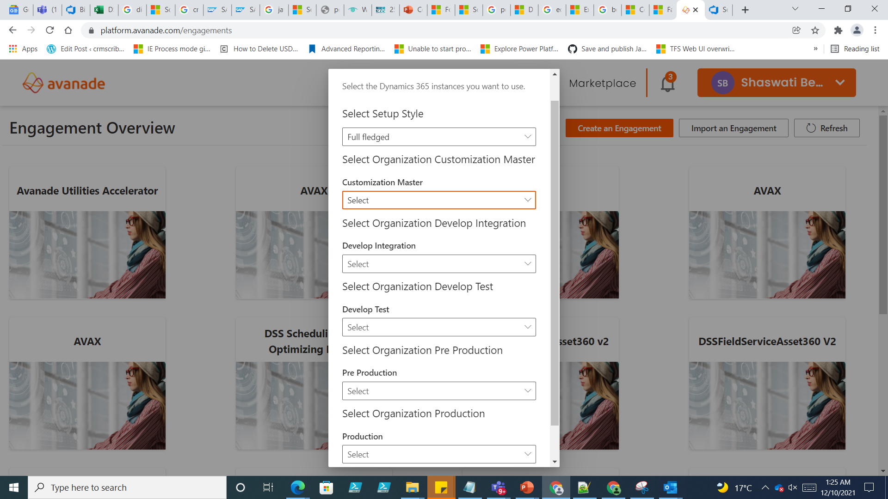

1. Enter the naming convention of the project.

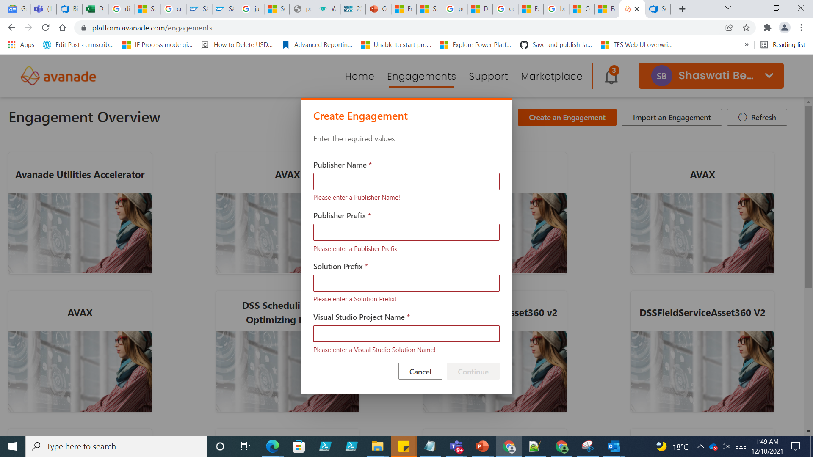

# Installing Tools

## Visual Studio Code

Download from: <https://code.visualstudio.com/>

## Visual Studio Professional 2022 or Visual Studio Enterprise 2022

Download from: <https://visualstudio.microsoft.com/downloads/>

## Install Tools (Manual) – refer to 3.4 for automatic installation

1. Git
2. NodeJS
3. Azure Artifacts Credential Provider – provided [link](https://github.com/microsoft/artifacts-credprovider)
4. Fiddler (Classic) – provided [link](https://www.telerik.com/fiddler/fiddler-classic)
5. Microsoft Power Platform CLI – provided [link](https://docs.microsoft.com/en-us/powerapps/developer/data-platform/powerapps-cli)

## Install Tools (Automatic using BizApps CLI)

1. Clone your project repository from Azure DevOps
2. Open Windows Powershell as Administrator and navigate to the cloned repository location.
3. Execute the below command.

Set-ExecutionPolicy -ExecutionPolicy Unrestricted -Scope LocalMachine -Force

1. Type .\bizapps-cli.ps1
2. Type 11 to select SetupLocalDevEnvironment

## Install NPM

1. Open Window Powershell as administrator
2. Execute the below command

npm install vsts-npm-auth -g

1. Navigat to \src\Dataverse\Web\ and run below command

vsts-npm-auth -F -config .npmrc

# DSS/BCA Source Code

## Update the Environments on Configuration.json

1. Use CustomizationMaster for the DEV Environment
2. DevInt can be used for Data Migration Environment. Please remove if not needed.
3. Use DevTest for the TEST Environment
4. Use UAT for the UAT Environment
5. Use Prod for the Production Environment

## Connection Strings

1. If user account with admin role is being used to connect to D365:

AuthType = OAuth

Username = <Username>

Password = <Password>

1. If service principal is being used to connect to D365:

AuthType = ClientSecret

ClientId = <ClientId>

ClientSecret = <ClientSecret>

## Dataverse Deploy

1. If “DevInt” is not being used, remove it from cicd/variables/dataverse-deploy.yaml.

#- template: templates/stages/deploy-generic.yaml

# parameters:

# environment_name: DevInt

# internal_name: dev_int

# depends_on: prepare_solutions

# upgrade_solutions: ${{ parameters.upgrade_solutions }}

1. Make sure that the first template has depends_on set to prepare solutions.

- template: templates/stages/deploy-generic.yaml

parameters:

environment_name: DevTest

internal_name: dev_test

depends_on: prepare_solutions

upgrade_solutions: ${{ parameters.upgrade_solutions }}

## Create Front End Solution

1. Open VS Code
2. Open the cloned repository folder
3. Open New Terminal
4. Type .\bizapps-cli.ps1
5. Type 9 to select NewSolution
6. Type 0 to select default publisher
7. Enter the solution display name (e.g. DSS10FrontEnd)
8. Do you want to create plugin, type 1 for No
9. Enter Client Id and Client Secret

## Create Back End Solution

1. Open VS Code
2. Open the cloned repository folder
3. Open New Terminal
4. Type .\bizapps-cli.ps1
5. Type 9 to select NewSolution
6. Type 0 to select default publisher
7. Enter the solution display name (e.g. DSS20BackEnd)
8. Do you want to create plugin, type 0 for Yes
9. Enter Client Id and Client Secret (if needed)

## Create MS Flows Solution

1. Open VS Code
2. Open the cloned repository folder
3. Open New Terminal
4. Type .\bizapps-cli.ps1
5. Type 9 to select NewSolution
6. Type 0 to select default publisher
7. Enter the solution display name (e.g. DSS30Flows)
8. Do you want to create plugin, type 1 for No
9. Enter Client Id and Client Secret (if needed)

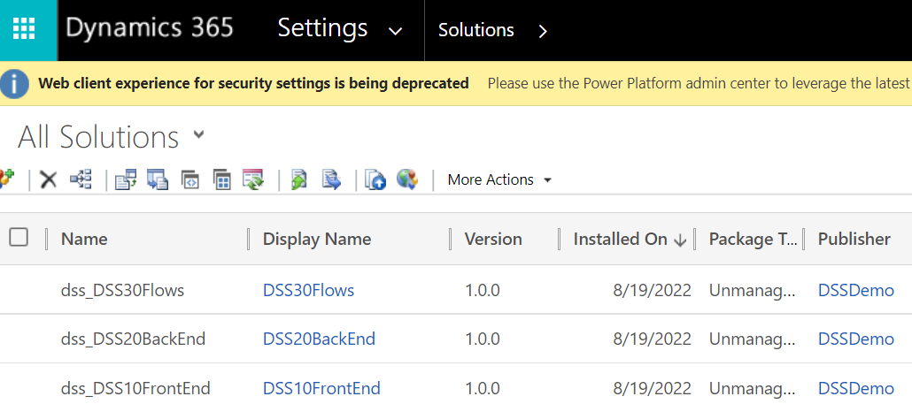

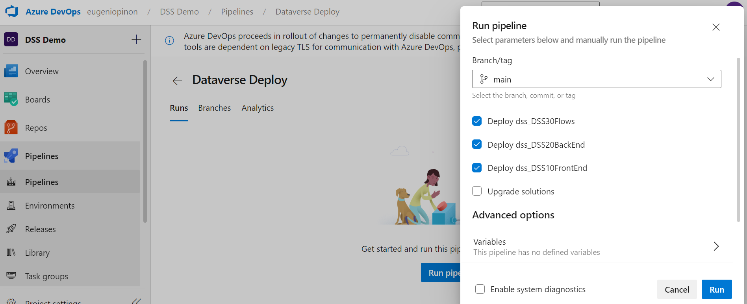

# Pipeline Library

## Dataverse Secrets

Pipeline Library 🡪 Dataverse Secrets

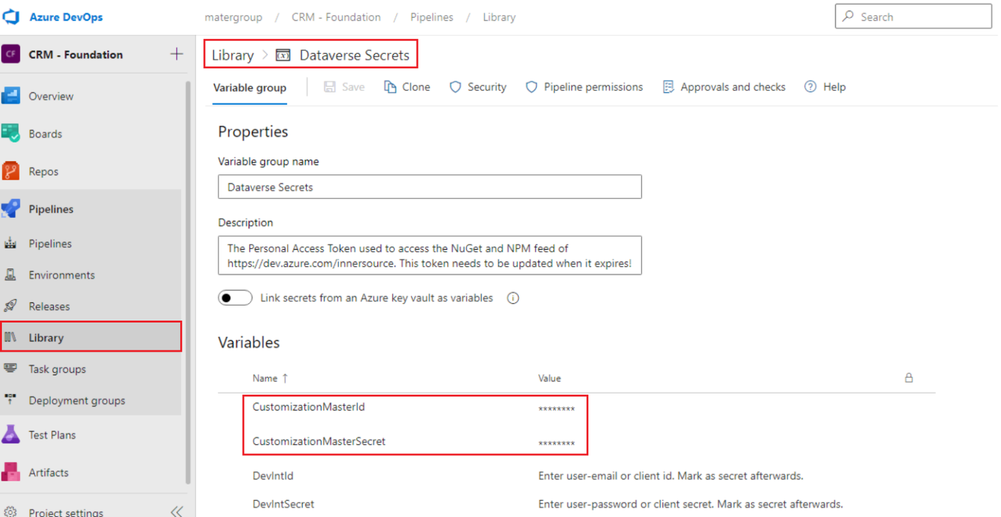

# Environment Deployment Approver

## Approval and Checks

1. Login to Azure Dev Ops
2. Navigate to Pipeline 🡪 Environment
3. Select the target environment you want to add approver
4. On the ellipses next to Add resource, select approvals and checks
5. Add checks
6. Select Approvals
7. Add user you want to be an approver, then click Create.

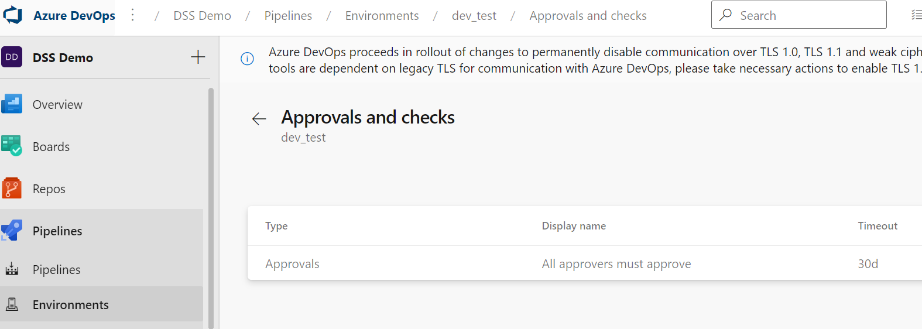

# Reference/s

## BizApps Core Accelerator

<https://docs.bizapps.avanade.com/BCA/3.0/>